# CLAP SWITCH CIRCUIT FOR HOME AUTOMATION PROJECT REPORT

**18CSS201J- ANALOG AND DIGITAL ELECTRONICS LABORATORY**

**(2018 Regulation)**

**II Year/ III Semester Academic Year: 2022 -2023** By

# SHAURYA SINGH SRINET (RA2111032010006) SHOUNAK CHANDRA (RA2111032010026)

Under the guidance of

# Dr. USHA S

**Assistant Professor**

**Department of Networking and Communications**



**FACULTY OF ENGINEERING AND TECHNOLOGY SCHOOL OF COMPUTING**

**SRM INSTITUTE OF SCIENCE AND TECHNOLOGY**

**Kattankulathur, Chengalpattu NOVEMBER 2022**

This is to certify that **18CSS201J – ANALOG AND DIGITAL ELECTRONICS LABORATORY project report** titled “**CLAP SWITCH CIRCUIT FOR HOME AUTOMATION”** is the bonafide work of **SHAURYA SINGH SRINET (RA2111032010006), SHOUNAK CHANDRA (RA2111032010026)** who undertook the

task of completing the project within the allotted time.

**Signature of the Guide**

Dr. Usha S **Assistant Professor** Department of NWC

SRM Institute of Science and Technology

A circuit which operates through clap sound otherwise like that sound is called clap switch. This switch activates once or twice clapped & deactivates when again clapped once based on the design of the circuit. Clap switch is an interesting hobby circuit which turns on the lights with a clap sound. Condenser Mic basically converts sound energy into electrical energy, that in turns used to trigger [IC 4017](https://www.futurlec.com/4000Series/CD4017.shtml), through a Transistor. The fundamental concept of the clap switch is that the microphone used in this circuit receives the clap sound & generates a small signal to controls a lamp. This clap detector or clap activated switch can be used for home automation. Generally, this switch is operated through sound. For instance, light, fan, etc. can be controlled through clapping.

This is a homemade clap switch control circuit with a relay. Therefore, any home appliance can be controlled with this clap switch circuit. Clap switch circuit components list: -

1. CD4017 IC
2. BC547 NPN Transistors
3. DC Condenser Mic
4. 100nf (103) Capacitor
5. 10K Resistors
6. 270K Resistors
7. 1M Resistor
8. 220-ohm Resistors
9. 1N4007 Diode
10. LED
11. 5V SPDT Relay
12. AC Lamp 220V/110V
13. 5V DC Supply
14. Breadboard

This clap detector or clap activated switch can be used for home automation to control light/fan with the clap. This DIY clap switch is one of the most useful CD4017 application circuits.

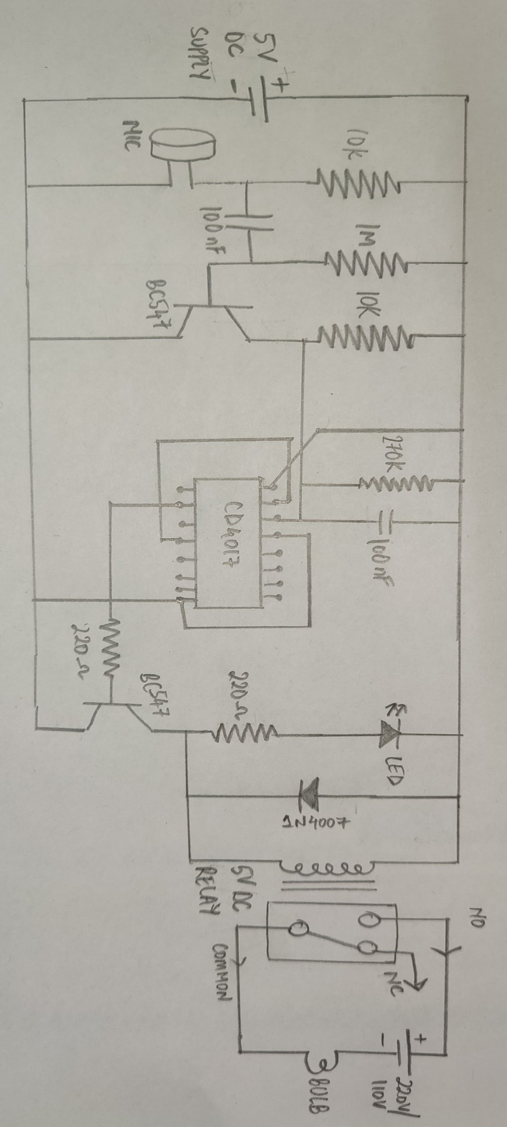

The CD4017 is a CMOS counter/divider IC. It receives a clock signal through the clock input and in the sequential manner it turns ON all the 10 outputs, every time it gets the clock input pulse.

To get familiar with the working of this IC, it is essential for the one to get familiar with every pin of this IC. This IC consists of 3 input pins along with 10 output pins also has one pin for ground and one more for the power supply and one more pin for the carry out. Pin diagram of this IC is designed below: -

# Input Pin:

* + **Reset Pin (Pin 15) –** The counter is reset to the zero position by this pin. Suppose you wish that the counter will only count till third position then you need linked the fourth pin with 15 pin. So, after reaching to the third output, it will automatically begin its counting from zero.
  + **Clock Pin (Pin14) –** In each of the timing pin 14 moves at high the output will be given to you. From the initial clock pulse output will be received at the pin 3 likewise for the next clock pulse output will be received at the pin 2 and so on.
  + **Clock Inhibit Pin (Pin 13) –** The counter is switched to “on” and “off” by this pin. If you need that the counter to be switched off, then for that pin 13 must be at high state. If the pin is at high, then it will disregard the clock pulse without paying attention that how much time you press the switch i.e., the count will not go forward. Pin 13 in our circuit is grounded.

1. **Output Pin (Pin Q0- Q9) -**It is used to get the input in chronological order. Like pin 3 will give you the output for the first pulse and so on**.**
2. **Ground Pin (Pin 8) and Supply pin (pin 16) –** For the proper working of this IC these pins are used to give ground as well as power supply.
3. **Carry out Pin (Pin 12) –** These pins are used to link one or more CD4017 IC with each other. Suppose you have a desire to connect one more CD4017 IC then attach pin 12 to the clock input to its next one. The carry pin of first CD4017 is connected to clock input of the second and the carry pin of the second is connected to the clock input of the third and so on. In our circuit we left this pin as we have desire of only one IC in our circuit.

The main component of this circuit is a CD4017 decade counter. An audio signal received by a device such as a mic serves as the input to the circuit. This inputs AC audio signal functions as a control signal to the base of a BC547 transistor.

The output from the collector of the BC547 provides a clock input to PIN 14 of the counter IC, subsequently triggering output pins Q0, Q1 & Q2 of the IC. Then, the output from the IC acts as a control signal to the base of the second BC547 NPN transistor & triggers the LED.

The output from the 2nd transistor energizes the coil of the 5V SPDT relay. This engages the relay & completes the circuit for an external output device such as a 220V/110V lamp bulb.

Here, we have used a diode (1N4007) to protect the SPDT relay from negative feedback in case of a short. Always use appropriately rated SPDT relays with respect to the input supply voltage

The advantages of the clap switch circuit include the following: -

1. The main benefit of clap switch is that we can control any electric load like light, a fan from any place in the room by clapping our hands
2. Energy-Efficient System
3. Less Cost
4. Circuit is Reliable
5. High Accuracy
6. Manpower is not Required

.

The disadvantages of the clap switch circuit include the following: -

1. The main drawback is that it is usually awkward to have to clap one’s hands to control the loads
2. It normally looks simple in most cases to utilize a normal light switch
3. Unnecessary disturbances may occur while operating in buildings

The above explained project has been executed and verified successfully.

Thus, the clap detector or clap activated switch was constructed and was used to control light/fan with the clap.

The report on Clap Switch Circuit for Home Automation has been made. The hardware of the project has been shown. The project corresponds to a real-life clap switch circuit for home automation that is used to control home appliances like light, fan, etc.

1. <https://youtu.be/KToo8p2EG-4>
2. [Clap Switch Circuit for Devices Circuit Working and Applications](https://www.electronicshub.org/clap-switch-circuit-for-devices/#Clap_Switch_Circuit_Description) [(electronicshub.org)](https://www.electronicshub.org/clap-switch-circuit-for-devices/" \l "Clap_Switch_Circuit_Description)
3. [Clap Switch: Circuit, Working, Advantages & Its Disadvantages (watelectronics.com)](https://www.watelectronics.com/clap-switch/)

1. [Best Clap Switch Circuit Diagram Using IC 4017 (ethcircuits.com)](https://ethcircuits.com/clap-switch-circuit/)
2. [How to Make Clap Switch | DIY Project | Home Automation | Electronics Projects (circuits-diy.com)](https://www.circuits-diy.com/how-to-make-clap-switch-diy-project-home-automation-electronics-projects/)